**SP17 HCI - UI Critique SNEHA PALVAI ROBOT: JIBO ( Family Robo)**

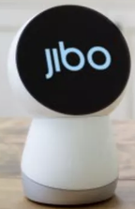

My topic Name: JIBO.

Co-Founder: Dr. Cynthia Breazeal

Appearance: It has a super cute shell-like structure with three-axis motor system. It has the circular face with two hi-res cameras, a speaker, 360-degree microphone, on board computer, wifi and Bluetooth connectivity. It’s feels like the presence of one our family member. Jibo is very sociable, smart and has matured system software and hardware.

Background:

Jibo is considered as world’s first family Robo. It is the most interactive device with all the members in the family. Jibo has inbuilt additional advanced features which accepts user’s voice commands and gives output accordingly. The user here refers to any member in the family or an employee/manager in the office, etc. everyone can use this. Facial recognition and natural language processing is used in order to enhance the user’s personal assistance at home.

User’s experience:

* Initially, user has to connect this Jibo to his on board computer through wifi or Bluetooth so that it can synchronize all the applications from the computer/mobile.
* It acts as best camera man. It captures photos of group pictures, individual photos by recognizing the facial gestures. Making sure everyone in the picture is happy. It can also take videos, by which user can enjoy the party without using their camera manually.
* Jibo facilitates the user to talk to it and acts as a hand free helper. For example, if I am busy cooking and my hands are dirty, Jibo talks to me directly and conveys exactly the same message as sent to it by anyone which is really an attractive feature.
* At times if we are so tired and really wants to refresh our mind, use can just talk to it to play some music/ listen to stories. Jibo acts like an entertainer as it has some special applications which facilitates adjusts the background light effects by itself along with the sound. Especially kids would love to listen to stories and play with it.
* The user can video chat with their family members, by rotating itself if we just give a single tap on the required other user’s face to interact with.
* It can help placing online orders for users just by talking to it.
* It answers any of our questions like weather forecast, sends emails to friends, helps us to playback our missed voice emails once we are back to home from work.
* For a businessman, it acts like a personal assistant reminding him about his meeting timings.

With all these I feel that JIBO works based on Fick’s Laws as the user has many choices to fulfill the task by selecting this option as the easiest choice. And also it meets the principle of learnability as any type of the user can learn many things just by speaking with JIBO. Feedback about this JIBO gave a 100% positive response from view of customer end. It also satisfies restoration property as the data can be recovered from the recycle bin of the onboard computer which operates JIBO.

Customer Satisfaction:

User doesn’t need to have any technical knowledge on how to use/operate JIBO. Any person can easily speak and enjoy the pleasure features offered by JIBO.

According to my view, I feel following below are few observations to be changed:

* Undoubtedly, JIBO is very expressive in showing happiness and sorrow. Though I have noticed that when JIBO smiles, the arc was shown upside down ☹ as its violating rules, but the head was pointing upwards. The arc should be like a smiling arc ☺. It should be set in a positive mode indicating happiness.
* It would be more attractive if JIBO is extended with cute little hands & legs enhanced with gesture features and body movements so that it would be more convenient.
* They can be connected to home appliances like coffee brewer to make coffee based on voice commands, set room temperature, automatic turn on/off the lights based on voice commands.

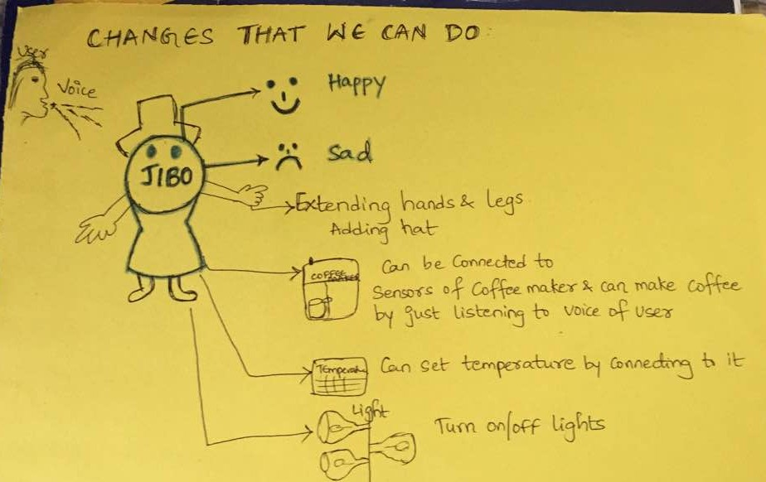

SIRI APP

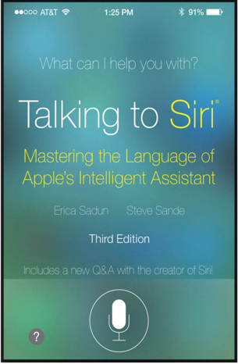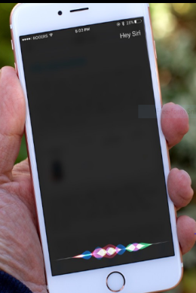

Name: SIRI

Co-founder: By Apple Inc. in 2010

Appearance: It looks like a microphone symbol on the display.

Background: In early 2000’s, Siri was initially started by SRI (Stanford Research Institute) and later on it was acquired as an app on apple iphone/ipad. Later it got extended to run on Macintosh computers that run OS X.

User experience:

* Now-a-days most of them are using apple iphones/ipads. On our iphone, we have SIRI app which really helps us to save little time in our busy life schedule.
* The user just have to press the microphone symbol in order to ask any questions of user’s day to day life by just using our own choice.
* Siri helps us to avoid usage of fingers on the mobile as it takes too long to type.
* It helps us to search any content by just tapping the button and speaking to it. Siri can send text messages/ dictate emails to user’s friends or colleagues while they are driving.

Customer satisfaction and feedback:

User’s are really happy as it works better than expected for few things. But they do not tend to use that more as it has some in voice recognition. To certain extent user can enjoy its features as it meets the principles of learnability. But sometimes it may violate the principle of consistency as the time taken to reach the target can be more if Siri has trouble understanding our language/accent. It violates the property of restoration property.

Few bugs which I feel to be changed:

SIRI has some voice recognition issues which may sometimes lead to frustration for users as it takes different accent for different voices.

Unlike JIBO, Siri doesn’t have any face recognition properties. We can add the sensors which recognizes them and use the feature to welcome the user as they are pleased to hear that.